Community Assessment Report

Anytown, USA

**Cover Page**

* Title
* Prepared by
* Date
* Sponsoring agency
* Other acknowledgments

Community Assessment Report Outline

I. Executive Summary

II. Introduction

A. The Anytown *Communities That Care* effort

1. About the Communities That Care system
2. Key accomplishments in Anytown

B. The risk- and protective-factor assessment

1. Goals
2. How the assessment will be used
3. Data collection methods
4. Prioritization methods

III. The Community Assessment Data

1. **Risk factors**
2. Community Domain
3. Family Domain
4. School Domain

4. Peer and Individual Domain

B. Protective factors

1. Community Domain
2. Family Domain
3. School Domain
4. Peer and Individual Domain

C. Problem behaviors

IV. Conclusion

1. Community strengths
2. Community priorities
3. Next steps

V. Appendices

1. **References**
2. **Acknowledgments**

**Executive Summary**

This report describes the results of the risk- and protective-factor assessment completed as part of Anytown’s *Communities That Care* effort. The *Communities That Care* system is a way for members of a community to work together to prevent youth problem behaviors, including substance use, delinquency, teen pregnancy, dropping out of school and violence. This system was developed by Dr. David Hawkins and Dr. Richard Catalano. It is based on their research, which has identified risk factors that predict youth problem behaviors and protective factors that buffer children from risk and help them succeed in life.

A key goal of the *Communities That Care* effort is to identify which risk factors, protective factors and problem behaviors are prevalent in our community, and implement evidence-based programs that address our community’s unique profile. To that end, the Risk- and Protective-Factor Assessment work group collected and analyzed data on Anytown. Then, with input from the community, they identified priority risk factors to address, as well as community strengths to build on.

The assessment was completed using the *Communities That Care Youth Survey* and publically available data. The *Communities That Care Youth Survey* was administered to students in grades 6-12 in all schools in Anytown in the spring of 2012. To get the most complete picture of our community, the Risk and Protective-Factor Assessment work group also collected data from public records to measure risk factors and problem behaviors not covered by the survey.

Based on the analysis of the data and input from the community, the following risk factors were identified as priorities for community attention:

* Low Neighborhood Attachment and Community Disorganization (Community Domain)
* Low Commitment to School (School Domain)
* Academic Failure (School Domain)
* Friends Who Engage in the Problem Behavior (Peer and Individual Domain).

These risk factors were selected as priorities for prevention action primarily because data indicated that they are significantly elevated throughout Anytown. The data also revealed Anytown’s strengths. For example, the *Communities That Care Youth Survey* revealed that students are motivated to follow society’s expectations and standards. They reported high levels of the protective factor “Belief in the Moral Order” and low levels of the risk factor “Rebelliousness.” This is an important area of strength on which to build to help promote well-being and protect our youth from the risk of health and behavior problems.

This report recommends that the community give particular attention to the risk factors noted above when developing the community’s action plan to prevent youth health & behavior problems and promote child and youth well-being.

Introduction

The Anytown *Communities That Care* Effort

In the spring of 2012, Anytown began implementing *Communities That Care* prevention planning system. Developed by Dr. David Hawkins and Dr. Richard Catalano of the Social Development Research Group in Seattle, Washington, the *Communities That Care* system is a way for members of a community to work together to efficiently and effectively promote positive youth development and prevent youth problem behaviors such as substance use, delinquency, teen pregnancy, dropping out of school and violence.

Anytown implemented the *Communities That Care* process to achieve the community’s vision that all young people in Anytown grow up supported and nurtured by their families, schools and community, and become healthy adults who contribute positively to society.

***Key accomplishments to date:***

* In March of 2012, community leaders attended a Key Leader Orientation and committed to the *Communities That Care* effort.
* In May, the *Communities That Care Youth Survey* was administered to 6-12th graders in Anytown schools.
* Also in May, a Community Board was formed. Members attended the two-day Community Board Orientation and established a structure for the Anytown *Communities That Care* effort. This included forming work groups to achieve the various steps in implementing the *Communities That Care* system.
* In June, the Risk- and Protective-Factor Assessment work group attended the Community Assessment Workshop and developed a plan for completing the community risk- and protective factor assessment. This report is the result of that assessment.

**The Community Assessment**

Dr. Hawkins and Dr. Catalano have identified risk factors that predict problem behaviors in youth, and protective factors that help protect young people from those risks. By addressing risk and protective factors, communities can help prevent adolescent problem behaviors and promote positive youth development. A key goal of the *Communities That Care* system is for communities to develop a profile of the risk factors, protective factors and problem behaviors in their community, and to develop a plan for addressing the risk factors that are most elevated while enhancing protective factors.

This report represents the first step in that process. The Risk- and Protective-Factor Assessment work group has collected data on risk factors, protective factors and problem behaviors in Anytown. With input from the community, the work group has identified our community’s strengths and the priority risk factors to address in the prevention plan.

***Data collection methods***

As noted above, the *Communities That Care Youth Survey* was administered in May 2012. All students in grades 6, 8. 10 & 12 were asked to participate. The complete results are provided in the Anytown *Communities That Care Youth Survey* report. In addition, Dr. Hawkins and Dr. Catalano have identified public data indicators that have been shown to be valid and reliable measures of certain risk factors and problem behaviors that are not measured by the survey, namely Extreme Economic Deprivation, Availability of Drugs and Alcohol, Teen Pregnancy and School Drop-Out. The Risk- and Protective-Factor Assessment work group collected data from local and state agencies to supplement the youth survey.

***How the priorities were identified***

The Risk- and Protective-Factor Assessment work group analyzed the data to identify which risk factors are most elevated in Anytown. This initial short list of priorities was presented to the Community Board, which discussed other considerations, such as the community’s ability to have an impact on certain risk factors at this time. By consensus, the Community Board then selected the final priorities for prevention action in Anytown. Those priorities were presented to Key Leaders for endorsement.

Report Overview

The next sections of the report provide detailed information and analysis of the risk factors, protective factors and problem behaviors in Anytown. The conclusion presents the final list of priorities and recommendations for future action.

**Risk Factor: Community Disorganization**

Higher rates of drug problems, delinquency, violence, and drug trafficking occur where people have little attachment to the community. Vandalism rates are high when there is low surveillance of public places. These conditions are not limited to low-income neighborhoods – they can also be found in more well-to-do neighborhoods.

Perhaps the most significant issue affecting community attachment is whether residents feel they can make a difference in their communities. Neighborhood disorganization makes it more difficult for schools, churches, and families to promote positive social values and norms.

The *Communities That Care Youth Survey* revealed that a majority of students in all grades surveyed are at risk for health & behavior problems based on their exposure to this risk factor. As Figure 3 indicates, students reported particularly high scores for Community Disorganization in comparison with the average for the *Communities That Care* normative population. Additionally, at 64%, Community Disorganization is the most elevated risk factor in comparison with other risk factors in Anytown.

For these reasons, this risk factor has been identified as a priority for Anytown.

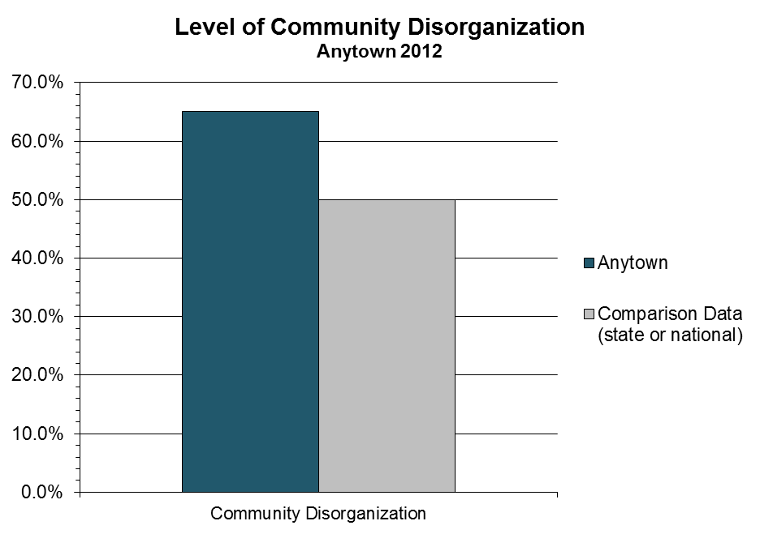

Source: 2012 Anytown Communities That Care Survey report

(Note: your comparison data may be national, state, or district. See example below with state comparison data).

**Risk Factor: Low Commitment to School**

Lack of commitment to school means the child no longer sees the role of student as meaningful and rewarding. Young people who have lost this commitment to school are at higher risk for five of the six health & behavior problems.[1]

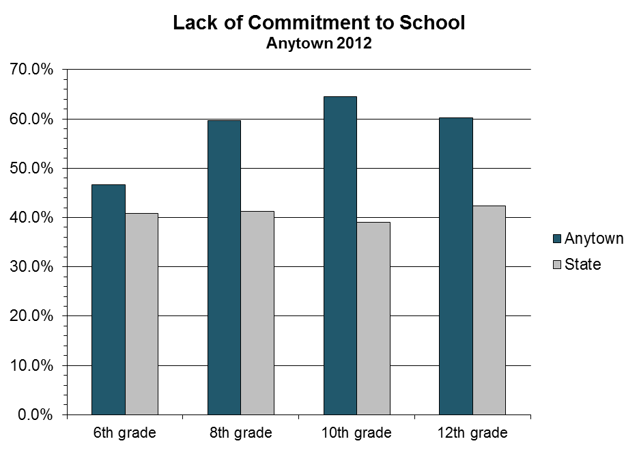

For the risk factor, Lack of Commitment to School, Anytown area youths at all grades show levels of risk exceeding State average levels.

**Risk Factor: <Name>**

Add text and charts for each subsequent risk factor to provide the rationale for selecting that risk factor as a priority.

Conclusion and Recommendations

Anytown’s Strengths

The data revealed that young people in Anytown are motivated to follow society’s expectations and standards. In particular, young people reported high levels of the protective factor “Belief in Moral Order” and low levels of the risk factor “Rebelliousness.” Anytown should work to build on this strength while enhancing other protective factors in its prevention efforts.

Community Priorities

Based on the analysis of the data and input from the community, the following priority risk factors were identified for the community to focus on over the next several years:

* Low Neighborhood Attachment and Community Disorganization (Community Domain)
* Lack of Commitment to School (School Domain)
* Academic Failure (School Domain)
* Friends Who Engage in the Problem Behavior (Peer and Individual Domain)

These risk factors were selected as priorities because the data indicated that they are among the most elevated throughout Anytown. We recommend that Anytown give particular attention to implementing strategies or programs to address these four risk factors when developing a prevention plan.

Next Steps

The next step in the *Communities That Care* process is to find out what resources are already in place in Anytown that address the priorities outlined above. The Resources Assessment and Evaluation work group will attend the Assessing Community Resources Workshop in November. Their assessment combined with this report, will make up the profile of Anytown that will be used to identify programs and strategies to promote child and youth well-being and prevent health & behavior problems in Anytown.

1. Boers, Reinecke, Seddig, & Mariotti, 2010; Catalano et al., 2011; Gottfredson, 2001; Guo, Hawkins, Hill, & Abbott, 2001; Jessor & Jessor, 1977; Kosterman et al., 2000; Najaka et al., 2001